Customer Demographic
Data Analytics Project
Short Project Report
Prepared by:Faysal Mohamed Dahir
Course: Excel for Data Analysis
August 2026

Introduction and Dataset (Part A)
This project analyzes customer demographic data using Microsoft Excel. The workflow follows the course requirement: collect, prepare, clean, analyze, visualize, and present data. The dataset is named Customer Demographic Data Analysis Data and was provided for the Excel for Data Analysis practical project.
The Raw_Data sheet contains 300 original records with 7 variables: Customer_ID, Registration_Date, Gender, Age, City, Occupation, and Monthly_Income. After cleaning, the Clean_Data sheet contains 293 usable records. The purpose of the dataset is to understand customer demographics, income patterns, city distribution, and registration trends to support business decisions.

Data Preparation (Part B)
The original data was imported into Excel and stored on Raw_Data without modification. Clean_Data was created as the working dataset. Data types were identified as Text (Customer_ID, Gender, City, Occupation), Number (Age), Date (Registration_Date), and Currency (Monthly_Income). Formatting was applied on Clean_Data including currency format for income, date format for registration dates, bold headings, and adjusted column widths.

Data Cleaning: Raw_Data vs Clean_Data
Seven rows were removed from Raw_Data (300 rows) to produce Clean_Data (293 rows). The main reason for removal was exact duplicate records where the same Customer_ID appeared with identical details. Duplicate IDs identified and removed included CUS00026, CUS00040, CUS00075, CUS00095, CUS00143, CUS00194, and CUS00224. Two fully empty rows at the bottom of the dataset were also deleted.
CUS00049 was investigated because it appeared twice in Raw_Data. One row was incomplete (missing Registration_Date and Age) while the other row was complete. The incomplete record was kept with missing fields handled separately; the complete registration information was preserved where available.
Blank Customer_ID values were not filled with fake IDs. Fourteen customers remain without a Customer_ID in Clean_Data, but their other information (Gender, Age, City, Occupation, Income) was kept because it is still useful for analysis.

Missing Values Handling
Missing values in Raw_Data appeared as blank cells, N/A, Unknown, NULL, and dash (-). Registration_Date missing values (20 records) were standardized to the label Missing. No fake dates were created. Gender, City, and Occupation missing values were replaced with Missing or Unknown so they remain visible in PivotTables and charts.
Age had 16 missing values in Raw_Data. All missing Age values in Clean_Data were replaced with the average age of approximately 44 years using AVERAGE on the valid Age column. Monthly_Income had 20 missing or invalid entries in Raw_Data including Unknown and dash. All missing income values in Clean_Data were replaced with the average monthly income of $923.87. This keeps totals and averages stable for PivotTables and dashboards.

Text Cleaning (Part C)
TRIM removed extra spaces, PROPER standardized capitalization for Gender, City, and Occupation, and SUBSTITUTE replaced CS with Civil Servant. Helper columns Gender_Clean, City_Clean, and Occupation_Clean were created on Clean_Data.

Analysis, Formulas, and PivotTables (Parts D-G)
The Analysis sheet contains formulas for basic calculations (SUM, AVERAGE, COUNTA, MIN, MAX), conditional functions (COUNTIF for Mogadishu customers, AVERAGEIF for Female income and Teacher average income), and logical functions (Nested IF for Income_Level: High, Medium, Low). Date functions included TODAY, NOW, DAY, MONTH, YEAR, DATE, and NETWORKDAYS. Reg_Year and Reg_Month columns were added to Clean_Data for time analysis.
Sorting was demonstrated using A-Z, Z-A, smallest-largest, largest-smallest, oldest-newest, and newest-oldest. Filtering answered questions such as customers in Mogadishu (110), Female customers (143), and multilevel filters like Female plus Mogadishu.
Conditional formatting used Data Bars on Monthly_Income and Color Scales on Age. PivotTables on the PivotTables sheet summarized data by City, Occupation, Gender, Income_Level, and Reg_Month using Rows, Columns, Values, and Filters areas.

Charts, KPIs, Slicers, and Dashboards (Parts H-J & K)
More than five charts were created from PivotTables including income by city, registrations by month, income by occupation, gender by city, income by gender, and yearly income. Dashboard 1 (Customer Demographic Dashboard) shows 4 KPI cards (Total Customers 293, Average Income $924, Mogadishu 110, Female 143), main charts, pie charts, and slicers for City, Gender, Occupation, and Reg_Month.
Dashboard 2 (Income and Occupation Analytics) shows KPIs for Average Age, Total Income, High Income Customers (22), and Teacher Average Income ($704), with charts for occupation, income level, and registration month trends plus Occupation and Reg_Month slicers.

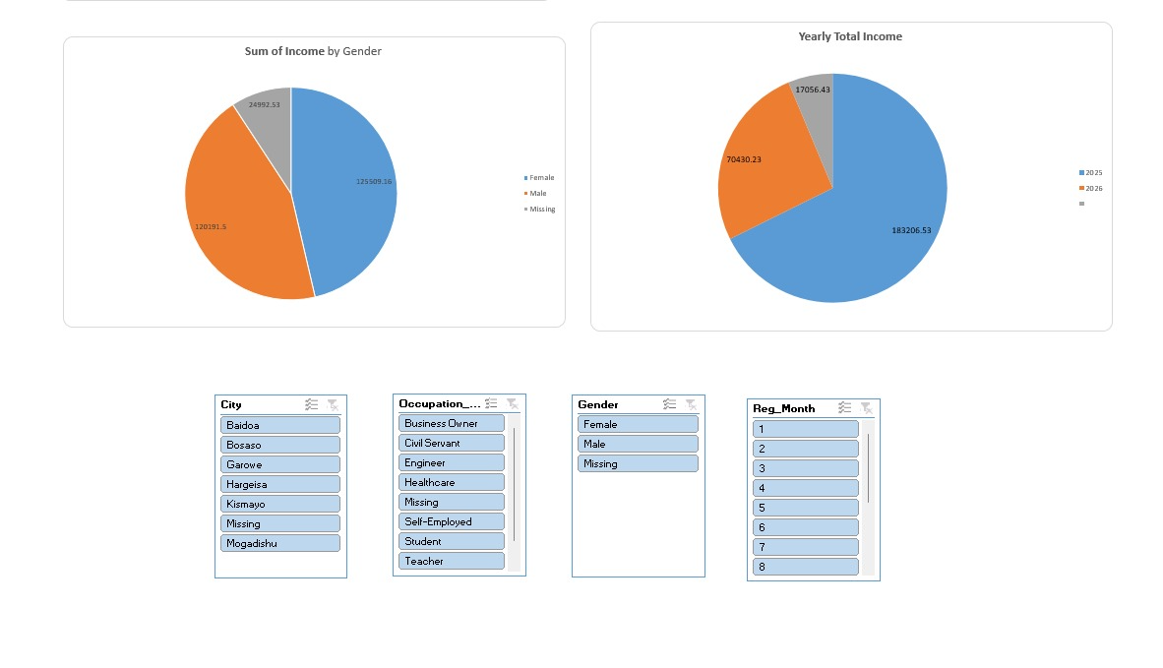
Dashboard Screenshots
Dashboard 1 - Part 1 (KPIs and main charts) 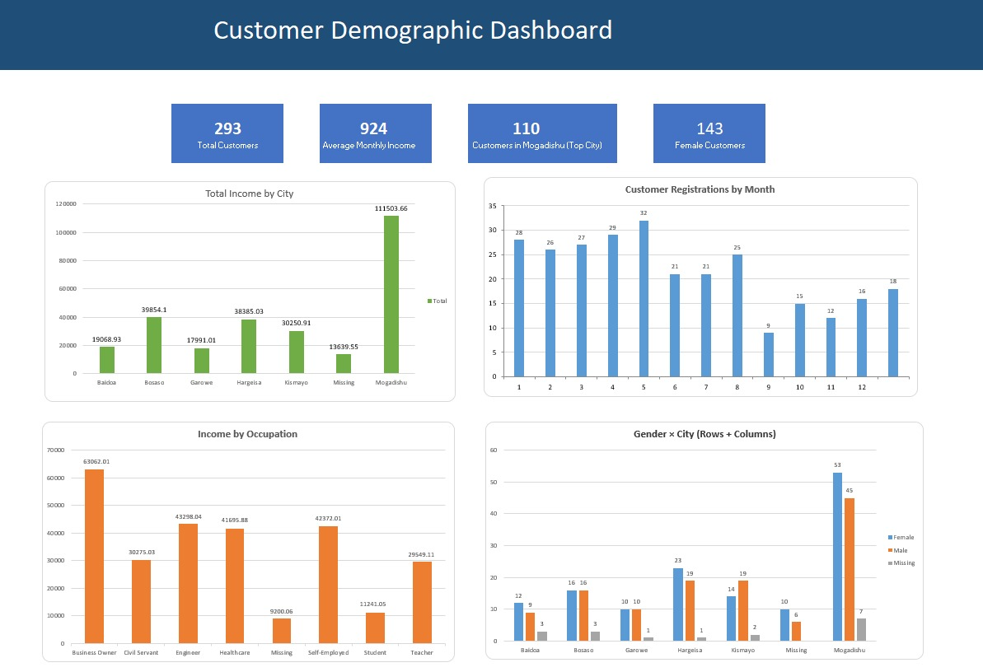Dashboard 1 - Part 2 (Pie charts and slicers)

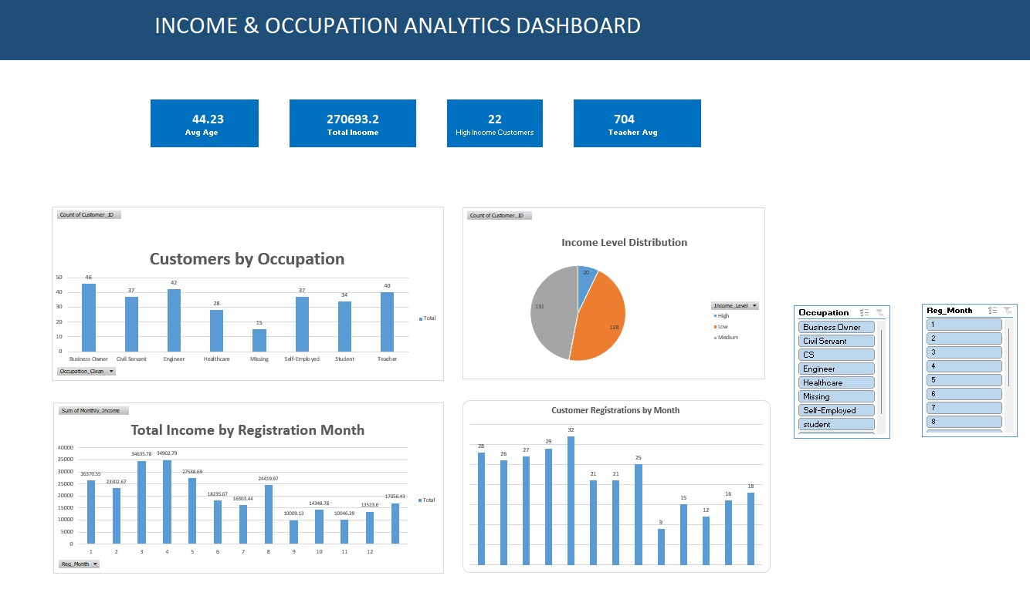
Dashboard 2 - Income and Occupation Analytics

Findings and Recommendations (Part M)
Finding 1: Mogadishu has the largest customer base with 110 customers and the highest total monthly income of about $111,504, representing roughly 41% of all income.
Finding 2: The average monthly income is $923.87 and the average customer age is 44 years.
Finding 3: Female customers (143) slightly outnumber Male customers (133) with similar average incomes (Female about $878 vs Male about $904).
Finding 4: Most customers fall into Medium and Low income levels. Only 22 customers are classified as High income (income at or above $1,500).
Finding 5: Business Owners and Healthcare workers have the highest average incomes. Customer registration activity peaked in May with 33 registrations.

Recommendations
Recommendation 1: Focus marketing and customer retention on Mogadishu because it is the largest and highest-revenue city.
Recommendation 2: Develop targeted campaigns for Female customers in major cities since they represent nearly half of the customer base.
Recommendation 3: Create income-based product offers for Medium and Low income customers and develop strategies to grow the High income segment.

Conclusion
This project completed the full Excel analytics workflow from Raw_Data through Clean_Data, formula analysis, PivotTables, charts, KPI dashboards, slicers, and written findings. Data cleaning removed duplicates and handled missing values carefully without creating false IDs or fake dates. The two dashboards and this report present the results clearly for decision-making.

